* Use the style attribute for styling HTML elements
* Use background-color for background color
* Use color for text colors
* Use font-family for text fonts
* Use font-size for text sizes
* Use text-align for text alignment

<body style="background-color:powderblue;">

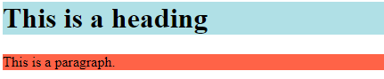

<h1 style="background-color:powderblue;">This is a heading</h1>  
<p style="background-color:tomato;">This is a paragraph.</p>

|  |  |
| --- | --- |
|  |  |
| <h1 style="color:blue;">This is a heading</h1> <p style="color:red;">This is a paragraph.</p> | <style>   h1 {color:red;}   p {color:blue;} </style> |



<h1 style="font-family:verdana;">This is a heading</h1>  
<p style="font-family:courier;">This is a paragraph.</p>

<h1 style="font-size:300%;">This is a heading</h1>  
<p style="font-size:160%;">This is a paragraph.</p>

<h1 style="text-align:center;">Centered Heading</h1>  
<p style="text-align:center;">Centered paragraph.</p>

**Underline**

